***ASSIGNMENT -06***

**1. Create a class MathOperation containing overloaded methods ‘multiply’ to**

**calculate multiplication of following arguments.**

**a.  two integers**

**b.  three floats**

**c.  all elements of array**

**d. one double and one integer**

class MathOperation{

static void multiply(int i,int j)

{

System.out.println(i*j);

}

static void multiply(float i,float j,float k)

{

System.out.println(i*j*k);

}

static void multiply(double i,int j)

{

System.out.println(i*j);

}

static void multiply()

{

int arr[]={1,2,3,4,5};

int p=1;

for (int i=0;i<arr.length;i++)

p=p*arr[i];

System.out.println(p);

}

}

class MethodOverloading{

public static void main(String args[]){

MathOperation.multiply(5,20);

MathOperation.multiply(10,20,30);

MathOperation.multiply(20,30);

//int arr[]={1,2,3,4,5};

MathOperation.multiply();

}

}

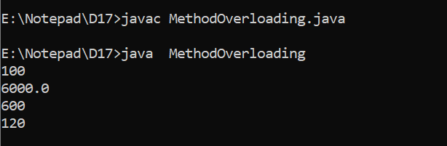

**2. Create a class Person with properties (name and age) with following features.**

**a. Default age of person should be 18.**

**b. A person object can be initialized with name and age.**

**c. Method to display name and age of person**

**Create another class PersonDemo ( main class ) that demonstrates the**

**functionalities of Person class by creating Person object and calling methods.**

import java.util.Scanner;

class PersonDemo62

{

public static void main(String arg[])

{

Scanner sobj = new Scanner(System.in);

System.out.println("Enter String");

String str = sobj.nextLine();

System.out.println("enter the age");

int no1 = sobj.nextInt();

Person pobj = new Person(str,no1);

pobj.display();

}

}

class Person

{

public String name;

public int age;

Person(String na, int num1)

{

if(num1 < 18)

{

this.age = 18;

}

else

{

this.age = num1;

}

this.name = na;

}

public void display()

{

System.out.println(name +" "+ age);

}

}

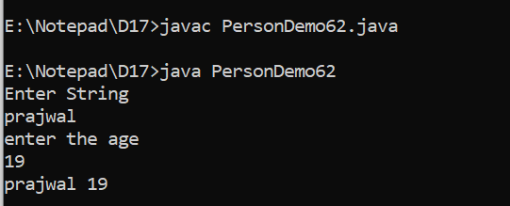

**3. Create a class Employee with three data members (empNo, salary and**

**totalSalary) and following features.**

**a. Only parameterized constructor. [Do not overload the constructor]**

**b. totalSalary always represents salary total of all the employees created.**

**c. empNo should be auto incremented.**

**d. display total employees and totalSalary using a method.**

**Create another class EmployeeDemo (main class) that creates some**

**Employee objects and calls Employee method to display no. of employees**

**and total of their salaries.**

import java.util.Scanner;

class EmployeeDemo63

{

public static void main(String arg[])

{

Scanner sobj = new Scanner(System.in);

System.out.println("Enter size of array");

int size = sobj.nextInt();

Employee arr[] = new Employee[size];

for(int i = 0, empNo = 1; i < arr.length; i++, empNo++)

{

System.out.println("Enter salary :");

int salary = sobj.nextInt();

arr[i] = new Employee(empNo, salary);

arr[i].display();

}

}

}

class Employee

{

public static int empNo = 0, salary = 0, totalSalary = 0;

Employee(int empNo,int salary)

{

this.empNo = empNo;

this.salary = salary;

this.totalSalary = (totalSalary + salary);

}

public void display()

{

System.out.println("Total employees are: " +empNo);

System.out.println("Total salary of all employees :" +totalSalary);

}

}

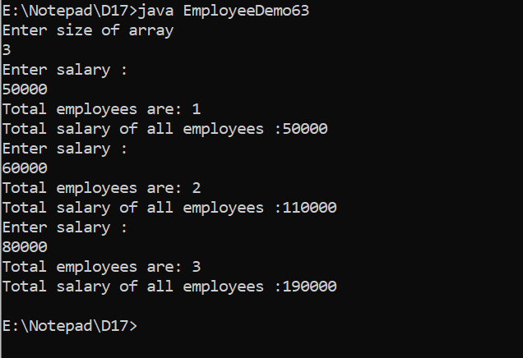

**4. Create class Product with three data members (pid, price, quantity) and**

**parameterized constructor that takes values for all three data members.**

**Create a main method in different class (say ProductDemo) and perform**

**following task:**

**a. Accept information for five Product objects from user and store objects in**

**an array**

**b. Find pid of product with highest price.**

**c. Create a static method (with array of product’s object as argument) in**

**Product class to calculate and return total amount spent on all products. (**

**amount spent on single product = price of product * quantity of product )**

import java.util.Scanner;

class Product{

int pid;

int price;

int quantity;

Product(int pid, int price, int quantity){

this.pid = pid;

this.price = price;

this.quantity = quantity;

}

}

class A6Q4{

public static void main(String args[]){

Scanner sc = new Scanner(System.in);

int [][]arr = new int[5][3];

for(int i=0; i<arr.length;i++){

for(int j=0; j<arr[i].length;j++){

System.out.println("enter elements");

arr[i][j] = sc.nextInt();

}

}

int max=0;

System.out.println("===================");

for(int[] ar : arr){

for(int a : ar){

System.out.print(a+" ");

}

System.out.println("");

for(int i=0; i<arr.length; i++){

for(int j=1; j<arr[i].length; j+=2){

if(arr[i][j]>max){

max=ar[j];

}

}

}

}

System.out.println(max);

}

}

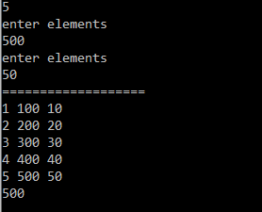

**5. Create a class Student having data members name, roll no., age and score.**

**Write a program to accept 10 records of student and store them in an array.**

**And then arrange the student records based on the score group [0-50], [50-**

**65], [65-80], [80-100].**

import java.util.Scanner;

class A6Q5

{

public static void main(String arg[])

{

Scanner sobj = new Scanner(System.in);

System.out.println("Enter the size of array:");

int size = sobj.nextInt();

StudentX arr[] = new StudentX[size];

for(int i = 0; i < arr.length; i++)

{

System.out.println("enter name");

String nm = sobj.next();

//sobj.nextLine();

System.out.println("enter roll no");

int rn = sobj.nextInt();

System.out.println("enter age");

int ag = sobj.nextInt();

System.out.println("enter score");

int sc = sobj.nextInt();

arr[i] = new StudentX(nm,rn,ag,sc);

}

StudentX1 obj = new StudentX1();

obj.display(arr);

}

}

class StudentX

{

public String name;

public int rollNo = 0, age = 0, score = 0;

StudentX(String n, int r, int a, int s)

{

this.name = n;

this.rollNo = r;

this.age = a;

this.score = s;

}

}

class StudentX1

{

public void display(StudentX brr[])

{

for(int i = 0; i < brr.length; i++)

{

if( ((brr[i].score) > 0) && ((brr[i].score) <= 50) )

{

System.out.print("score group 0-50 :");

System.out.println("Name:"+brr[i].name+" "+"Rollno:"+brr[i].rollNo+" "+"Age:"+brr[i].age+" "+"Score:"+brr[i].score);

System.out.println(" ");

}

else if( ((brr[i].score) > 50) && ((brr[i].score) <= 65) )

{

System.out.println("score group 51-65 :");

System.out.println("Name:"+brr[i].name+" "+"Rollno:"+brr[i].rollNo+" "+"Age:"+brr[i].age+" "+"Score:"+brr[i].score);

System.out.println(" ");

}

else if( ((brr[i].score) > 65) && ((brr[i].score) <= 80) )

{

System.out.println("score group 66-80 :");

System.out.println("Name:"+brr[i].name+" "+"Rollno:"+brr[i].rollNo+" "+"Age:"+brr[i].age+" "+"Score:"+brr[i].score);

System.out.println(" ");

}

else if( ((brr[i].score) > 80) && ((brr[i].score) <= 100) )

{

System.out.println("score group 81-100 :");

System.out.println("Name:"+brr[i].name+" "+"Rollno:"+brr[i].rollNo+" "+"Age:"+brr[i].age+" "+"Score:"+brr[i].score);

System.out.println(" ");

}

}

}

}

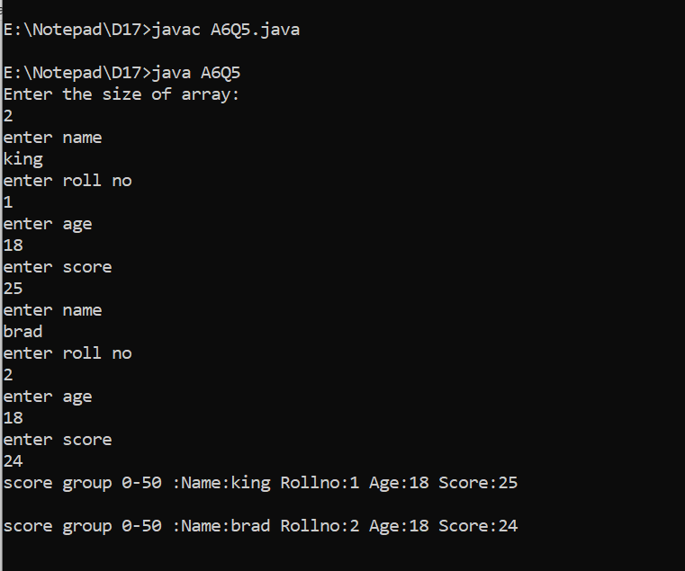

**6. Write a program to demonstrate this() construct functionality.**

class Employee{

int empId;

String empName;

Employee(){

this(100,"ABC");

System.out.println("no arg");

}

Employee(int empId,String empName){

System.out.println("parameterized");

this.empId = empId;

this.empName = empName;

}

void show(){

System.out.println(empId+" "+empName);

}

}

class ThisConstruct{

public static void main(String args[]){

Employee e = new Employee();

e.show();

}

}

